MTE 546 Multi-Sensor Data Fusion Lab Manual

# Contents

* Academic Integrity
* Lab Overview
* Report Guidelines
* Lab 1: Sensor Modelling
* Lab 2: Extended Kalman Filter
* Lab 3: Complete Sensor Fusion System

# Academic Integrity

1. As a UW Student you are expected to know what constitutes an academic offence and be familiar with Policy 71 of the University of Waterloo. For details please review the following:  
   <https://uwaterloo.ca/secretariat-general-counsel/policies-procedures-guidelines/policy-71>

In particular, academic offences of note are as follows

* 1. Cheating: Cheating includes copying from another person’s work, allowing another student to copy your work, submitting another person’s work as your own, fabrication of data or unauthorized use of aids
  2. Plagiarism: Plagiarism is the presenting of another’s work, intentional or not, as your own. This can be for graded or ungraded purposes but is reviewed in the same manner

1. You are to complete the labs between you and your partner. While it is reasonable to ask other students questions, it is not reasonable for two groups to hand in identical reports. The reports will be submitted to a single dropbox on Learn.
2. If you require the use of someone else’s code or data, please make sure to clearly declare this information. A reasonable possibility for this is outlined at the beginning of Lab 2

# Lab Overview

In this lab you will gain the opportunity to apply the algorithms you have learned in class in a lab environment. You will be using a set of Sharp IR sensors to determine the distance of different objects, and then integrating the results with a set of thermocouples to localize a heat source. The lab is broken up into parts covering the different topics and levels of multi-sensor data fusion.

# General Report Requirements

The following guidelines apply to all lab reports submitted for this course

1. The lab report must be completely done by the members submitting the report. If, for whatever reason, there is a section done by another student that is not acknowledged and given proper credit, a mark of zero will be recorded
2. Your report should be self-contained and complete. Be sure to answer all questions outlined in the lab manual. The marker should be able to reproduce your results based on your report alone
3. Always discuss any differences that you may see and use your best judgment to explain any discrepancies
4. Always include proper units when discussing your results
5. Please provide clear comments and variable names

# Please explain any assumptions you have made. Even if the assumption is incorrect the marker will take them into account. Lab Due Dates

|  |  |
| --- | --- |
| Lab | Due Date |
| Lab 1 Report | January 26th 2018 11:59 PM |
| Lab 2 Report | February 16th 2018 11:59 PM |
| Lab 3 Report | March 26th 2018 11:59 PM |

# Lab 1 – Sensor Modelling

## Goals:

* Model sensor output of IR distance sensor over a set of distances
* Characterize sensor uncertainty using a probability distribution
* Compare sensor operation to the sensor data sheet

## Description

In this lab you will gain an opportunity to apply the techniques learned in class to properly model and characterize a set of Infrared (IR) Sensors. You will be given 4 IR sensors to work with; 1 short, 1 medium and 1 long distance sense. In addition you have your choice of one 1 duplicate sensor to work with. From the data sheets posted on UW-Learn, determine appropriate output measurement ranges and sample rates (from the timing chart listed on the data sheet) that you will be using.

Data analysis can be performed using your preferred tool (MATLAB, C++, Excel, etc.) However, your analysis should be properly accompanied with the corresponding calculations used to develop your program. Please note, the model that you develop in this lab will be used for future labs. So make sure you are confident in your methodology.

Answers to questions in the lab report should be kept brief and can use sentences, point form, equations, and/or sketches (take a clear photo to include in the document) where appropriate.

## Setup

You will be modelling the Sharp IR Sensor line using a cube of aluminum, a meter stick and the NI ELVIS II+ Board. You will determine a proper orientation and setup using the meter stick and aluminum for each corresponding sensor. The sensors connect to the ELVIS Board as follows

Sensor

+5v

Analog Input Signals DAQ

AI n+

AI n-

**Ensure that you have the corresponding sampling rate for the appropriate sensor.**

Adjust the height accordingly for each of the sensors on the sensor mounts.

You can collect the data using the MATLAB Script provided on UW-Learn.

## Sensor Model

For each of the three types of sensors (short, medium and long distance) collect data by:

1. Placing the sensor at a distance representing the closest position for its operating range as given in the sensor’s data sheet
2. Recording a set of measurement samples of the output voltage
3. Moving the sensor further away and repeating the process

Your measurements sample set should cover the entire operating range of the sensor (e.g. 10 cm, 20 cm, … 80 cm for the medium distance sensor).

After you have collected the data, for each of the three sensors:

1. For each set of measurement samples (e.g. measurement samples at 30 cm) determine the mean output voltage of the measurement set
2. Plot distance vs. mean output voltage for the sensor
3. Fit an appropriate line or curve to this data to determine the equation modelling the sensor
$$voltage=f(distance)$$

4. Compare the values produced by the equation with the corresponding mean output voltages, and state the maximum error (difference) and the average error; is it reasonable to assume zero mean Gaussian noise to model the error?
5. Compare the plot and line/curve fit to the information in the data sheet,
   1. Describe the similarities and differences
   2. What is the maximum voltage difference between the two?
   3. State at least one possible cause for the differences between the sensor operation given in the data sheet and your measurements
6. For each set of measurement samples (e.g. measurement samples at 30 cm) for the given sensor
   1. Plot the histogram of the measurement samples
   2. Fit a normal (Gaussian) distribution to the measurement sample data; Comment on any outliers and how they affect the distribution
   3. State the standard deviation, variance, and the goodness of fit for the measurement set
7. Compare the histograms and normal distributions for all the sets of measurement samples for a given sensor:
   1. Are the histograms similar in shape? For any that are significantly different, give a reason why they might be different.
   2. Are the variances similar?
   3. If one variance is to be used for modelling the sensor over its entire range of operation, what is a reasonable variance to use? Why?

State the sensor model equation and assumed Gaussian noise:

$voltage=f\left(distance\right)+ η$ where $η= N(0, σ^{2})$

1. Give the inverse equation $distance=g(voltage)$

## Two Sensors

Set up your system so that it has two sensors (of different types or the same type) that provide competitive distance measurements. Collect measurement samples from both of the sensors at five different distances.

1. Sketch or provide a photo of the measurement setup.

For the measurements at each distance:

1. Use the sensor model determined above for the corresponding sensor type to convert the measurements to be distance measurements.
2. How do the measurements compare between:
   1. The two sensors
   2. Sensor 1 and the ruler distance
   3. Sensor 2 and the ruler distance
   4. The average of the two sensors and the ruler distance

Comment on the results obtained.

1. For any larger than expected errors, state why the sensor may have performed poorly.

## Different Sample Rates

Collect sensor measurement data for a faster sampling rate (e.g. 10X faster at 1 ms compared to 10 ms).

1. For the measurements at different sample rates,
   1. Did the change in sample rate have an impact on the sensor measurements?
   2. Looking at the sensor measurements over time, is there a periodic pattern to the error or does it resemble white noise? If there is a pattern, does changing the sample rate have an impact?

## Other Conditions

## Collect sensor measurement data under at least two “other” conditions such as:

* Different reflective material
* “Block” at an angle

1. When operating under “other conditions”,
2. Describe how you changed the measurement set up (include a photo or sketch if needed)
3. What was the impact of the change in conditions on the performance of the sensor? Was this what was expected given how the sensor operates?

## Report

Submit the report file with answers to questions, plots, simulation files, and any photos to the drop box on UW-Learn.

# Lab 2 – Sensor Fusion with EKF

## Goals:

* Develop a simulation of a sensor fusion system that uses the Extended Kalman Filter to fuse competitive information from multiple distance sensors that sense an object in motion
* Characterize the performance of the fusion system in simulation
* Compare the results of the simulation to the actual performance of the system

*Note: You will be using your sensor models from Lab 1 as part of Lab 2. If you feel there are issues with you models (e.g. problems with reference voltage, broken sensor, etc.) you are welcome to use Lab 1 information from another group so long as you acknowledge their contribution.*

***Before going to the lab, you should have completed the setup and simulation parts of this lab.***

## Description

In this lab you will gain an opportunity to apply the Extended Kalman Filter in a laboratory setting. Before being able to apply the filter, you will develop the motion model of a block and simulate its motion in MATLAB. The simulated results will be compared to those obtained in the lab and evaluated using appropriate metrics.

## Extended Kalman Filter Definition

You will be using two (or more) of the IR distance sensors to sense the object as it is slowly moved.

1. How do do you intend to move the object with respect to the sensors?
2. Define the state vector, $x_{k}$, to be used for the system

Recall: $x_{k+1}=Ax_{k}+ω$

When selecting states, think about what is needed to completely characterize the system in terms of position, velocity, and possibly acceleration for the intended movements

1. Define a suitable linear system model for the movement.
   1. If needed, what is a reasonable time step, $T$, and why?
   2. Give the system matrix $A$, and a noise matrix $Q$ (select the values to reflect how well you think your actual motion in the lab will match your linear model of motion), and briefly explain your choices
2. Determine the sensors to be used for the measurements. How many sensor measurements are needed given the number of states? Provide a sketch for the setup of the sensors.
3. Referring to your results from Lab 1, define a suitable non-linear sensor model for the system.

Recall:

* 1. Give the sensor model function $h(x_{k})$)
  2. Give the linearized sensor matrix $H_{k}={\left.\frac{∂h}{∂x}\right|}_{{\hat{x}}_{k,k-1}}$
  3. Define a suitable sensor noise matrix $R$; You can assume the noise is zero-mean Gaussian noise (even though this is inaccurate for the sensors) and that the sensor noise is independent, refer to your results from Lab 1 to justify your choices

## Simulation Implementation

Use MATLAB, Simulink or another suitable tool to develop a simulation of your system. With the simulation you will be able to compare the state estimates with the known values of your simulated object motion and can examine the covariances as a measure on uncertainty. Figure 1 shows a block diagram of the simulation.

Noise

Simulated Object Motion

Sensor 1 Model

Sensor 2 Model

Extended Kalman Filter

Noise

$$y_{2k}$$

$$y_{1k}$$

$$y_{k}$$

Noise

$${\hat{x}}_{k,k}, P_{k,k}$$

Figure 1 - Simulation Layout

1. To explore the operation of the Extended Kalman Filter, simulated sensors are used to generate measurements under more controlled conditions
   1. Implement the sensors models for the selected sensors $y_{k}=h\left(x_{k}\right)+η$ in the simulation
   2. Verify that the measurements generated are reasonable given your results from Lab 1
   3. Implement object motions that represent the motions to be tested in the lab
2. Implement the Extended Kalman Filter based on your equations from above

Simulation

Run the simulation with the defined object motions and simulated sensors with:

1. Two different initial state estimates (one good, one poor), and comment on any differences seen in the resulting state estimates
2. Two different sets of sensor noise (one with covariances similar to those represented by your sensor model, one with higher levels of noise), and comment on the resulting state estimates compared to the “known” values under the different conditions
3. Two different sets of system noise (one with covariances similar to those represented by your system model, one with much higher levels of noise), and comment on the resulting state estimates compared to the “known” values and the covariance matrix $P$, under the different conditions
4. Three different motions of the object (one similar to the system model, one significantly different, one where the object does not move) and comment on the resulting state estimates compared to the “known” values and the covariance matrix $P$, under the different conditions

Include the code and screen shots of your simulation in your report, as appropriate.

## Experimentation

Configure your sensors as described in Step 1. Collect data for:

1. Object motion similar to your model $(A)$
2. Object motion different than your system model
3. Random motion
4. Stationary object
5. Under poor sensing conditions (viz. one of: poor reflection, near the edge of the sensor operating range, different object, or another condition)

Run the Extended Kalman filter on your data (you can replace the simulated motion and simulated sensor parts of your simulation). And for each of the above, comment on the results obtained, and how they compared to your simulated results.

## Report

Submit the report file with answers to questions, plots, and any photos to the drop box on UW-Learn.

# Lab 3 – Complete Sensor Fusion System

## Goals

* Implement all levels of a complete sensor fusion system
* Use different sensor types to fuse data to localize a heat source
* Use effective decision making techniques to correctly identify the location of a heat source

## Description

In this lab you will be attempting to locate the position of a heat source on a sheet of metal. The metal will be equipped with thermocouples and IR sensors. You will fuse the information from the sensors and then apply decision making logic to identify the location of the heat source. This lab will provide you an opportunity to compare sensors with different rates of reaction, as well as apply decision making logic.

## Setup

Each team will be given a 10 cm X 10 cm aluminum sheet with five thermocouples attached in the following configuration

Based on the above configuration, determine the placement for four IR Sensors. You will be given one long range, one short range, one medium range and a duplicate of your choice. **Be sure to include the drawing of your layout in your report along with a photo of your physical layout.**

Your heat source will be a 30 mm x 30 mm module

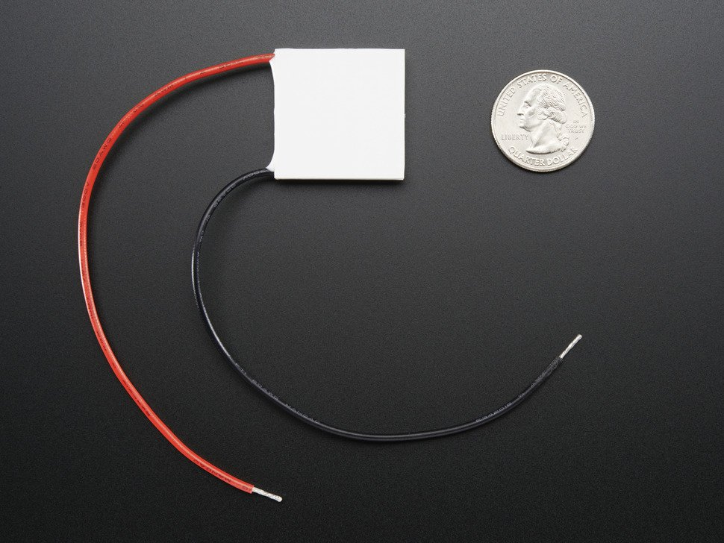

Figure 1 - Heat Source (https://www.adafruit.com/products/1331)

### Thermocouple Setup

The thermocouples you have been provided are braided K Type thermocouples with built in analog amplifiers. Using the pigtail to alligator clip connectors provided, clip the alligator clips to the connectors of the thermocouple braid, and the pig tail to the block connector on the amplifier.

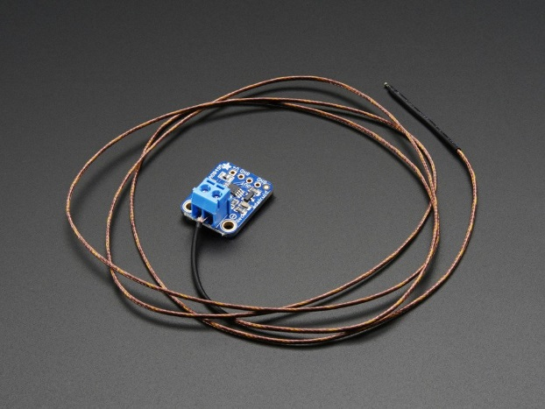

Figure 2 - Thermocouple Image from Adafruit (<https://www.adafruit.com/product/1778>)

Plug the thermocouple into the ELVIS Board and connect the power, ground and output to the amplifier according to the labels.

You will be able to determine the relationship between the amplifier output and the temperature with the following equation

$$T=\frac{V_{out}-1.25}{0.005 V}$$

## Simulation

1. Using the setup that you designed, develop a simulation that models the IR sensors receiving information to fill an occupancy grid of the metal sheet.
   1. Test the simulation with three different test cases and comment on how quickly the sensors are able to localize the heat source.
   2. What cases would the IR sensors be best suited for? Which are they unable to handle?
2. Using the provided thermocouple training data (or your own if you so choose) model the physical setup outlined above and develop a simulation that fills an occupancy grid of the metal sheet
   1. Test the simulation with three different test cases and comment on how quickly the sensors are able to localize the heat source.
   2. What cases would the thermocouples be best suited for? Which are they unable to handle?
3. Combine the IR Sensor and Thermocouple simulations in one scheme
   1. Test the simulation with three different test cases and comment on how quickly the sensors are able to localize the heat source.
   2. What are the advantages and disadvantages of the fused system

## Experimentation

With your working simulations, implement the various configurations on the physical system. *The aluminum plate will heat up and cool down relatively slowly!* Be sure that you are confident in your simulation before implementing it in the lab

For each of your test cases be sure to take a picture of the lab setup to compare the computer output with the actual system.

1. Using just the IR system attempt to localize the heat source
   1. Perform two different test cases with just the IR system
   2. How do the experimental and simulated results compare?
2. Using just the thermocouple system attempt to localize the heat source
   1. Perform two different test cases with just the thermocouple system
   2. How do the experimental and simulated results compare?
3. With the fused system attempt to localize the heat source
   1. Perform two different test cases with the entire system?
   2. How do the experimental and simulated results compare?
   3. What is the cost associated with using the fused system?

## Report

Submit the report file with answers to questions, plots, simulation files, and any photos to the drop box on UW-Learn.